VISUAL ART
Institutional Affiliation
Name

Visual art is an imprecise umbrella term that categorizes art broadly and addresses several artistic disciplines from a wide range of sub-categories. It requires that one should deeply interpret arts rather than composing a diluted meaning or definition about it. A visual art has several categories according to the activities involved in the art. These include fine arts, contemporary arts, and decorative arts and crafts (Visual Art).
Fine arts belong to the general category of visual arts and deals with painting, drawing, printmaking, manuscript illumination, calligraphy, architecture, and sculpture. Contemporary arts, on the other hand, includes a wide range of modern art forms, for instance, assemblage, collage, mixed media, installation, conceptual art, performance art, and photography as well as film-based artwork such as photography, animation, and video art. Decorative art and craft also fall under the general category of visual arts. It includes disciplines such as ceramics and studio pottery, mosaic art, mobiles, tapestry as well as glass art. Visual art can also be classified as applied art which includes graphic design, fashion design or interior design, and body art which includes tattoo art, body painting or face painting.
Question 3
Marshall Maynard Fredricks, born in January 31st, 1908 and died on April 4th, 1998 at the age of 90, was an American sculptor. Due to his impressive work during his existence, he managed several awards including the National Sculpture Society Medal of Honor, American Institute of Architects Gold Pine Arts Medal, Architectural League of New York Gold Medal of Honor Michigan Academy of Science, Arts and Letters Gold Medal and National Sculpture Society Henry Hering Medal. A museum, Marshall M. Fredricks Sculpture Museum was named after him in memory of his great job.
This museum was established on May 15, 1988, under Mrs. Dorothy Arbury who was then on the board. It is located within Saginaw Valley State University at the Arbury Fine Arts Center in Michigan, the university center (Museum History). His artwork is displayed in the main exhibit gallery section of the Marshall M. Fredricks Sculpture Museum. This section displays an extraordinary collection of the work under his career. It includes bulks of plaster molds used to make the sculptor’s work in bronze. These were given by Marshall to the museum and helped in installation in the permanent exhibit.
Figure 1.1 The Lion and the Mouse (Museum History)
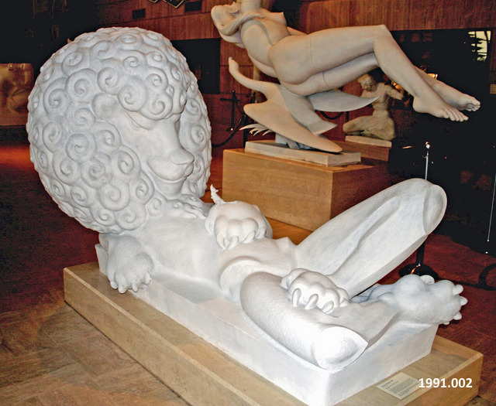
One of his sculptures is called The Lion and Mouse. It was created in the year1957 under animal sculpture in the 20th century and is made of plaster full-scale. It has physical dimensions of 54” * 36” * 77” and has a catalog number 1991.002. It is the first plaster model that was made by Fredericks and was commissioned by J.L. Hudson Company to be made for Eastland Shopping Center in St. Clare shores. This sculpture was moved from the shopping center to the museum gallery since it is the original one and was replaced by another one where the lion is made of limestone and the mouse, on the lion’s paw is made of bronze and plated with gold (Marshall, 2011).
This sculpture is based on the story of the "lion and the mouse" which explains how helpful the wee, little mouse in the story was helpful to the huge lion though, the lion could not believe it. The lion wanted to eat the little mouse but the mouse appealed for a chance that one day he will help the lion and surely, he did according to the story. The sculpture, with the huge lion's posture and a little mouse at his paw, show a great picture of nature. It shows the kind of relationship that should exist between all beings, whether big or small, that everyone is important to the other. No one is complete on his/her own.
According to the story, the lion did not see the significance of the mouse in his life, maybe eating the mouse could be the best option for him but after letting him go, the little mouse came out to rescue the huge lion (Scott, 2017). Fredricks captured very well the lion's reaction to the little mouse being of such a small size, the kind of help he could give him. The posture of the lion poses some kind of underestimation to the little mouse on his pow. As per the sculpture, the mouse lifts up his head towards the lion's huge head with so much confidence that they are of equal importance to one another. To me, this sculpture that every being should treat the other as an important tool in their life.
Question 6
Album art, the art presented on the covers of record albums, compact disks or DVDs is used to capture the attention of the viewers and also explain what the album or disk is trying to address. This kind of art started in the year 1938 when Alex Stienweiss came up with the idea of artwork on album covers and as started it himself by designing the very first cover with the original design replacing then existing cardboard in slip which only had the name of the album and a stamp on the album with the artist's name. by the late 1940s, all the major companies had their own colorful paper covers featured in their record albums (Jspraget, 2013). Other companies followed the same and some created the original designs.
Photography was quickly involved which was used alongside the artwork to create album covers. There was no great impact on album covers through World War II though there was a lot of music produced then. During the 1950s the album cover stayed much similar to the artist and a collection of bright colors was displayed. However, there was a noticeable improvement in the album artwork in the 1950s than 1940s. In the late 1960s, creativity started showing up in the artwork since cartoon drawings could be used and as well as quality photography which gave a modern look to the albums. The first computer-imaging was made in the year 1973 which involves developing images using computers (Chilton, 2018). This brings about a wide range of effects and styles which makes the album artwork more interesting. Album art became much more controversial in the 1980s though it used the black theme. Computer graphics came about in the 1990s and later in the 21st century which saw the album art very much developed.
Currently, album art has become very useful in explaining the album and a well as informing the reader about what to expect in the album. It has been of much importance in that it is the first interaction of the consumer with the artist’s work. It also helps to compete for attention for several records on the same rank in the record store. A cover concept also can act as the starting point for other visuals. An album art is the best opportunity for an artist to distill his/her own brand into a single image that can with time, become their brand itself. A good album cover can help artists to catch important business figures. A strong visual can tell the seriousness of an artist about his/her craft before diving into the music itself (Skelton, 2018).
Figure 1.2 Nevermind (Staff, 2018)
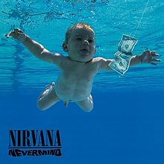
For instance, in the “nevermind” album of the Nirvana rock band from America which was produced in 1991, the artist used an album art of an underwater naked baby approaching a dollar bill on a string. This resembles a fishing practice where fish are caught using this kind of trick. As the album name states, the artist tries to show how the society never mind what they are getting the youth through. This art poses a sad statement about the values the society passes to the youth. The artist captured well the society at large that they may be aware of what is happening to the youth so that they can withdraw from the bad practice (Staff, 2015).
In conclusion, visual art is of great importance to society as they can help people learn what is really happening amongst them. Most of the art is cultural so it helps the society to know more about their culture and know what is expected from their daily deeds and practices. Visual art is also a source income since the beautiful crafts create beautiful scenery when they are put together in order. They as well need personnel to help to interpret the message being passed through them since different people will interpret different arts differently, therefore, getting different meanings.

References
Visual Art: Definition & Meaning. (n.d.). Retrieved from http://www.visual-arts-cork.com/definitions/visual-art.htm
Museum History. (n.d.). Retrieved from http://marshallfredericks.org/about/history/
The museum, Marshall M. (2011, July 08). Lion and Mouse. Retrieved from https://www.flickr.com/photos/marshallfredericks/5915045275/in/album-72157627146083402/
Scott, G. (2017). The lion and the mouse. New York, NY: Windmill Books.
Jspraget1 Follow. (2013, January 15). The History Of Album Art. Retrieved from https://www.slideshare.net/jspraget1/the-history-of-album-art
Staff, B. (2015, November 12). The 50 Greatest Album Covers of All Time. Retrieved from https://www.billboard.com/photos/6715351/best-album-covers-of-all-time
Chilton, M. (2018, September 01). Cover Story: A History Of Album Artwork. Retrieved from https://www.udiscovermusic.com/in-depth-features/history-album-artwork/
Skelton, E. (2018, June 01). Why Cover Art Is More Important Than Ever. Retrieved from https://pigeonsandplanes.com/in-depth/2017/04/should-we-still-care-about-cover-art

